USER INTERFACE DESIGN

EXPERIMENT 4: Create a prototype with familiar and unfamiliar navigation elements. Evaluate ease of use with different user groups using proto.io

NAME: GAYATHRI BOOPATHY REG NO: 240701141

AIM:

The aim of this experiment is to design and develop a Social Communication App prototype incorporating both familiar and unfamiliar navigation elements, and to evaluate its usability among different user groups using Proto.io.

PROCEDURE:

Step 1: Sign Up and Log In
- Go to https://proto.io
- Sign up for a new account or log in if you already have one.

Step 2: Create a New Project
- Click on “Create New Project.”
- Give the project a name (e.g., “Social chat App”).
- Select the device type (Mobile – iPhone X).
- Click “Create” to start the project.

Step 3: Design the Login Screen
- Add a new screen named Login
- Add UI elements:
  - App logo at the top
  - Welcome text (“Welcome Back”)
  - Input fields for Email/Username and Password
  - Login button
  - “Forgot Password” and “Sign Up” links
- Add Interaction:
  - Trigger: Tap on Login button
  - Action: Navigate to “Chats” screen

Step 4: Design the Chats Screen
- Add UI elements:
  - Header with “Chats” title
  - Search bar
  - List of chat users with profile images
  - Status indicators (Active / Last seen)
  - Bottom navigation bar (Chats, Calls, Profile)
- Familiar Navigation Elements:
  - Search bar
  - List-based chat UI
  - Bottom navigation bar
- Unfamiliar Navigation Elements:
  - Tap on profile to open details
  - Gesture-based interactions (if applied)

Step 5: Design Profile Screen
- Add UI elements:
  - Profile picture
  - Username and bio
  - Stats (Posts, Followers, Following)
  - Buttons (Edit Profile, Share)
  - Tabs (Photos, Videos, Tagged)
- Add Interaction:
  - Bottom navigation → Navigate between screens
  - Tap buttons → Trigger actions (Edit/Share)

Step 6: Link Screens
- Login → Chats screen
- Bottom navigation:
  - Chats → Chats screen
  - Calls → Calls section (optional)
  - Profile → Profile screen

Step 7: Preview the Prototype
- Click “Preview”
- Test:
  - Login functionality
  - Navigation between tabs
  - Profile interactions

Step 8: Conduct Usability Testing
- Define User Groups:
  - Group A: 18–22 years (High tech knowledge)
  - Group B: 30–40 years (Moderate tech knowledge)
  - Group C: 45+ years (Low tech knowledge)
- Assign Tasks:
  - Log in to the app
  - Search for a contact
  - Open a chat
  - Navigate to profile
  - Switch between tabs
- Collect Feedback:
  - Task completion time
  - Errors encountered
  - User satisfaction rating (1–5)

Step 9: Analyze and Evaluate
- Compare how different user groups interacted with familiar and unfamiliar navigation elements.
- Identify difficulties faced by users.
- Summarize findings and suggest improvements.

Output:

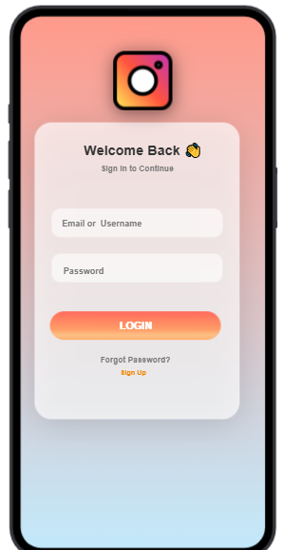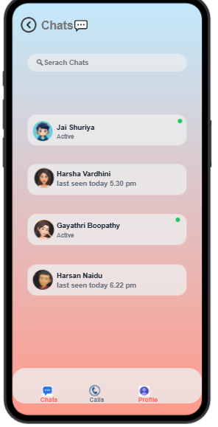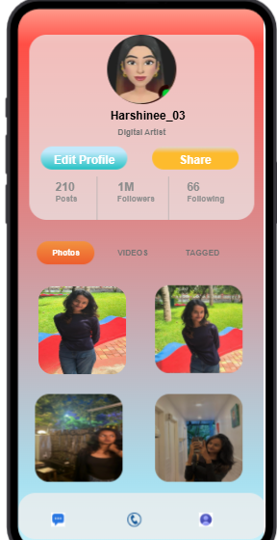

Prototype link:
hthttps://pr.to/5IY3VY/

Result:
The Social Communication App prototype was successfully developed using Proto.io. The usability evaluation showed that familiar navigation elements improved ease of use across all user groups, while unfamiliar elements required additional learning, especially for users with lower technical experience.

